Name____________________________ Date___________ 12 Days of Christmas
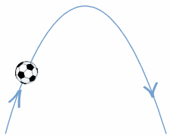
What would it cost for your true love to give you the gifts of the 12 Days of Christmas?
Open Excel.
- In cell A1 type: Day
- In cell B1: Gift
- In cell C1 type: Cost Each
- In cell D1 type: Extended Cost

Tip: If you find that the titles don’t fit, widen the columns by putting your cursor as shown and dragging them.
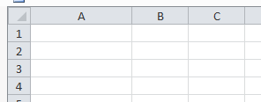

- In cell A2 type: 1
- In cell A3 type: =A2+1 Then press enter
- Fill down from A3 through A13. (Control + D)
- In cells B2 through B13, type the name (not the quantities) of the gifts. You may have to widen the columns again. You will find the list of the gifts on the next page.
- In cells C3 through C13, type the individual cost of each of the gifts. This is also found on the next page.
- In cell D2 type: =A2*C2 Then press enter
- Fill down from D2 through D13
- In cell C14 type: Total Cost Then set the font to boldface.
- In cell D14 type: =sum(D2:D13) Then press enter
- Click the D at the top of the column. Then click the $ sign at the top of the page.. What does this do the numbers in column D?
_________________________________________________________________
- Which gift has the highest individual cost? ____________________
- Which day has the highest cost? ____________________
- What is the total cost of your true love’s gifts? ____________________
- What would be the total cost if the most expensive gift was on sale for 25% off and the leaping lords were buy one—get one free? ____________________
Submit your spreadsheet when you finish.
On the twelfth day of Christmas
my true love sent to me:
12 Drummers Drumming
11 Pipers Piping
10 Lords a Leaping
9 Ladies Dancing
8 Maids a Milking
7 Swans a Swimming
6 Geese a Laying
5 Golden Rings
4 Calling Birds
3 French Hens
2 Turtle Doves
and a Partridge in a Pear Tree

Store Receipt:
Thanks for shopping with us!

Drummer $245.00
Piper $239.00
Leaping Lord $52.43
Lady Dancer $839.00
Milk Maid $7.25
Swan $1,000.00
Goose $33.00
Gold Ring $150.00
Calling Bird $150.00
French Hens $52.50
Turtle Dove $62.50
Partridge $15.00
Pear Tree $49.95

