“When are we ever gonna use this?”
And other annoying math questions

W
e math teachers are often asked to address some specific and bothersome questions that other teachers are privileged to avoid. Like missiles launched our way, these salvos take us and our students off the topic and task of the day and may make us even regret our career choice. My goal is to provide you with some witty counter measures, some answers that will satisfy your most vocal adolescent adversary. Herewith are my lighthearted responses to five responses of the most common questions I hear.

- “Do I have to show my work? I can do this in my head.”
“Then just turn in your head,” I answer, “but that will probably only work once.” This answer generates a laugh, but it won’t prevent a student from asking the same question the next day. Teens are persistent if they are anything.

The next time someone asks if they need to show their work or can just do the work in their head, I go to my desk and pretend to make a phone call. My end of the conversation goes like this:
“Hi coach, it’s Mr. Fulton here. I have a question for you. We have two seconds left in the basketball game; we’re down by one; and I’ve just been passed the ball under our basket. I’m standing in my sweet spot. You’ve seen me make this shot a hundred times in practice, so you know I can do this. Can I just think about shooting the ball in my head and get a couple of points?...
“No? I have to actually shoot the ball instead of thinking about it?” Then I pretend to hang up, and I tell the student that apparently knowing how to make a basket doesn’t get you any points.
Even this skit will not dissuade the most persistent student. I still get asked this question the next day. When that happens, I go back to my desk for another fake phone call.
“Hi, principal. Hey, I was wondering…I’ve been teaching middle school for over half my life. I know if forwards and backwards. I could do it in my sleep. Can I stay home tomorrow and think about teaching and still get paid my full salary...Hello...Hello? Hmm, they hung up on me. Apparently, I have to actually do the work to get my pay check.”
The students enjoy the show, and I explain that every job I know requires you to not merely know how to work, but to actually show up and do it. I ask them if they can think of any exception; so far, they haven’t.
If a student asks the next day if they have to show their work, the other students yell, “Don’t ask! He’s gonna pick up the phone again. Of course, you have to show your work!”
- “I did half my work; can I get half credit?”
Many teachers will allow this – especially with younger students. This is understandable, and there is nothing wrong with that approach. As a teacher of eighth graders who would be leveling up to the rigors of high school the following year, I wanted to prepare them for this.

I explained that I only graded completed assignments. I also explained that I only drive across completed bridges. I also avoid surgeons who do only 99% of their job and forget to sew the patient up when finished.
I also acknowledged that when they were younger, the bar wasn’t set as high and in high school it might be even higher. As adults, they would get paid when a job was finished. I asked them if they knew what time I get to go home after school is out. The answer is, when I finish my work.
I explained to them that as young children, much of their life was play. However, they are becoming adults with all the power and privileges that goes with that. And in the wisdom of Spiderman’s uncle, “With great power comes great responsibility.”
Now, I want to reiterate that it is perfectly acceptable for you to give partial credit if that is what you want to do. However, if you want to move students toward a higher standard, that is also acceptable. You will have to decide what is best for your students and where to put the bar.
I tell my students (and their parents at conference time) that this will be a slow process and gradual learning curve as they progress from childhood to adulthood. It’s challenging to transition from the world of child’s play to the world of adult work. They will make mistakes along the way, and this is okay.
With that in mind, I must remember that just because I demand completed work doesn’t mean that I will get that. Sometimes students will forget to do one problem or not understand one problem. I have to differentiate between that situation and the student who habitually makes a minimal attempt at their work.
Even the student who has developed the habit of not completing work is somewhere along the road on this journey to adult responsibility. My goal is to see progress. I’m never punitive or demeaning when a student doesn’t do their work. After all, it is a problem that hurts them, not me, so I want them to see the effect that this has on them.
Sometimes, I will call a student up to my desk and show them the difference that one missing assignment had on their grade. I put a temporary grade in place of the zero they earned and show them how their grade jumps. Many students don’t realize how much one missing assignment has.
Here is a link to an activity that helped my students understand the value of doing their work:
- Catch Up: problem solving, applying algebra to understand the importance of doing one’s work
- “Is it okay if I turn in my work late?”
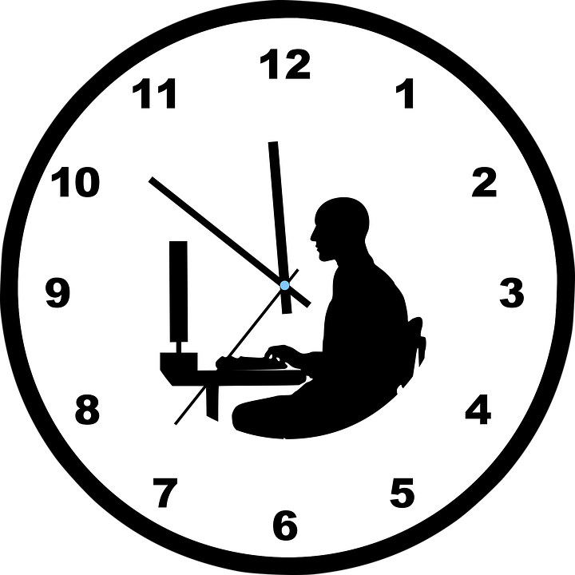

Teachers have many different policies on late work, and it’s not my purpose to transition you to my policies. However, we all have the same goal: we’d love it if all students turned in their work on time. Part of the reason that we have such varying policies on late work arises from the fact that late work has such varying consequences in real life.
For example, I once heard an English teacher say that she was “the DMV of grading.” “When you fail your driving test,” she explained, “you don’t get an ‘F’; you get to try again. There is no record of what happened before.” She is right, the person who gets their license at 18 is not more successful than the one who gets it much later.
She went on to say that if a student did not show mastery of a concept in October, they could do that assignment over again the last week of school, and she would grade it. In many ways, this is a logical and fair approach that focuses on mastery and allows students to progress at their own rates without penalty. There was no penalty for late work in her class. On the other hand, she had a ton of essays to grade at the end of the school year.
We often justify our approach to late and missing work by trying to find a real-life comparison as this teacher did. That is fine, but it may also lead to problems and contradictions. In this case, the teacher has a good model for her policy on late work, but it gives the student the impression that it is all right to do work late. Few employers would accept that.
It also gives the impression that learning at your own rate is a good approach to life in general. While this is true in most cases, it is a very bad approach to sky diving. If you want to take up that sport, you need to get a 100% on every attempt. Learning later is learning too late for a skydiver.
I think it is best to keep in mind that homework and classwork are a hybrid experience that has no perfect corollary in real life. Sometimes, it’s okay to do it right instead of doing it fast, and other times, such as catching a plane, almost is no good at all.
I tried to implement a policy on late work that reflected the maturity level of the students. Younger students should get more leeway than more mature students. I told my students that the highest grades would be given to students who did their work on time and did it completely. If a paper was a bit late, it wouldn’t have full credit, but it would get more credit than one was later still. I also have a cutoff time after which I no longer accept a late assignment. I imposed these policies in my class with eighth grade students.
With that in mind though, I do bend my policy often. If a student simply forgot their work once, I might not count that late at all. If it’s habitual, I’m less lenient. This sort of subjective response is not wrong; feel free to be flexible with your students as you see fit.
I also give every student one work pass at the start of each grading period. Everyone will forget something at some point, and I don’t want to penalize them for being human. This pass doesn’t exempt them from doing the assignment; it allows them to turn in one assignment late without penalty. If they don’t use the pass, they can sell it back to me at the end of the grading period for extra credit. To avoid theft of these passes by other students, they have to sign their pass in ink when they first receive it. When they use it, they staple it to the late assignment. I remove, destroy, and discard it and then grade the paper as if it was on time.
Here are two links to papers that explain how I managed assignments, paper work, and late work in my math class:
- Managing the Math Class for Maximum Success, Volume 1
- Managing the Math Class, Volume 2: Ending the Paper Chase

- “That’s not the way I learned it when I was a kid!”

This is one that I hear from parents who are trying to help their child with homework. I also hear it a lot every time that my state comes out with a new math framework. Let me begin with a troubling story that ended happily.
After California adopted the Common Core State Standards, someone posted on social media about their displeasure with this new-fangled way of doing math. As often happens, this person posted a silly math problem that they attributed to Common Core. The problem was not part of the Common Core, but that didn’t limit the onslaught of mocking comments about the Standards.
Instead of taking the high road, I took the same tone by mocking the critics. That didn’t go well. What it did accomplish was to invite the wrath of the critics to land on me. Things got ugly. The person who originally posted pointed out that he often did work in his head and didn’t need some convoluted new strategies.
It occurred to me that that is what the Common Core Standards are all about: doing math in conceptual ways with understanding instead of procedures. I knew that I had to defuse this angst if I was going to make any headway on the issue.
I checked the man’s profile and found out that he was an older self-employed father of two and a veteran as well. I began my second attempt by first thanking him for his military service. This was sincere and not designed to be condescending or manipulative.
I then explained that it would be easy for me to teach math the way that he and I learned it in school. This put he and I on the same page in that we had some common ground. However, I reminded him of how much the world has changed since we were in school. When I began high school, there was no such thing as a calculator that could fit in a pocket. By the time I began my teaching career, they were common and inexpensive. The math that he and I spent years mastering could now be done more quickly, accurately, and cheaply by a pocket calculator or phone.
In fact, I reminded him, no employer would hire his children based on their ability to do pencil and paper math as he and I did. Now I was appealing to his concern for his children’s welfare. I told him that my goal was to ensure that his children would be competitive in the job market with students from other nations.
We ended with a respectful and positive exchange of comments, and the other naysayers quit posting on the feed.
This experience taught me how to engage parents who have strong negative opinions about how I teach. I understand their frustration. When their child is struggling, they want to help. It must be extremely frustrating and demeaning for an adult to look at a child’s textbook and realize that they don’t understand it.
Parents and teachers have a common noble goal: we want the best for their child. Now when they complain about math standards, modern textbooks, and modern strategies, I thank them profusely for having the courage to bring their concerns to my attention. Then I ask them to tell me what they dislike about that.
Often, they tell me that they don’t like the state standards, but they can’t tell me specifically what it is they object to about it. Their misconceptions often are the result of what they see on social media or some biased source.
When I asked one parent what they didn’t like about the standards, she said, “It’s just all the stuff I hear on the news.” I smiled and asked, “According the news, what does every airplane do?” The answer is, all airplanes crash.
I went on to explain that the news will only showcase what is negative and wrong. I go on to say that many nations are outperforming America in mathematics. Many businesses are having to hire workers from other nations in order to get the mathematical expertise they need. Our state standards are an attempt to bring American students up to the level of international students.
We can’t give our children our education and expect them to be prepared for today’s jobs. A colleague of mine, high school math teacher, Bill Lombard, once phrased it this way: “Are we preparing them for their future, or for our past?” When parents realize that my motivation and approach is in the best interest of their child, I typically win them over to my side.
“Are we preparing them for their future, or for our past?”
–Bill Lombard
Whether your state utilizes the Common Core State Standards for Math or some other standards, this approach with parents still works. Here is a link to a letter I sent to all parents when the CCSS for math first came out:
- A Letter to Parents about Common Core
- “When are we ever gonna use this?”
Have you ever noticed that this question only gets asked in math classes? Why is that? When I was in high school, we dissected a pig in science class, and I learned to do a backflip on a trampoline in physical education. I have never had to dissect a pig since then, but it didn’t occur to me at the time to object to learning that skill. I had fun cutting up that little creature and finding out what made it tick.

And wouldn’t it be funny if you were in an interview for a teaching position and the administrator said, “It’s between you and one other candidate. We’re going to bring in a trampoline, and whoever can do the best back flip…” I’ve had to bend over backwards for a few jobs I’ve had, but I’ve never had to do a back flip. I’m sure I knew at the time that this wasn’t a job skill, but I didn’t question the p.e. teacher.
So why do we get asked this question in math? I suspect that it has nothing to do with application to real life, for I know that a lot of what I learned in middle and high school was not something that I would later use.
In fact, I get the highest student engagement when I teach my science unit on astronomy. The kids are constantly asking question about distant stars and alien life even though none of them will ever go to another solar system nor be abducted by an alien. Clearly, the question has nothing to do with application.
I suspect that it has something to do with fascination. Let’s face it; we are math teachers, and we don’t think like the general population. We think numbers are pretty cool. Most people do not. And when they see that what we are doing may not apply to real life (insert dividing mixed numbers or finding the surface area of a cone here), they look for a justification to disengage.
I don’t blame them. As math teacher, author, and presenter Edward Zaccaro says, “Math is often taught as all scales and no music.” To overcome this question then requires that we teach the beauty of the music of mathematics.
That doesn’t mean that we can’t teach some scales along the way, but our brains demand to be hooked, to be intrigued, to be shocked!
For that reason, I look for lessons that have a bit of the unexpected. For example, I show the students the Fibonacci sequence that shows up so prevalently in nature.
1, 1, 2, 3, 5, 8, 13, 21, 34, 55, 89, 144…
I also ask them to divide a number by the one before it as they move down the line. For example, 144÷89 is approximately 1.618 which is remarkably close to the Golden Ratio.
But what if I mess with this? Let’s start with -8 and 3:
-8, 3, -5, -2, -7, -9, -16, -25, -41, -66, -107…
It turns out that -107÷-66 is also close to the Golden Ratio. It is approximately 1.621. Hmm…is that a coincidence? Did I set that up intentionally by starting with those two numbers? Your brain wants to know. My students will want to test this on numbers of their own choosing. They will be practicing integer addition in an engaging way! The fact that this order can erupt from the randomness of our universe is one of the most beautiful aspects of math.
Now here’s the best news: as I have transitioned to this teaching approach through the years, one of the outcomes has been that students never ask me, “When am I ever gonna use this?” Though I know that some of what I’m teaching they will never need, they don’t question it because it is engaging – like a video game. No child will ever need to shoot zombies for a living, but that doesn’t stop them from their addiction to their electronic games.
Here are links to some of my activities that provide engaging mathematics:
- Leo’s Pattern: practice with addition and subtraction of any numbers, problem solving, solving proportions, solving equations
- Hundreds Magic: practice with addition and subtraction of natural numbers and integers, looking at algebraic proofs
- Algebra Man Project: using algebra to do magic on the hundreds chart
- Horses, Pigs, and Cows: practice with addition and subtraction of any numbers, solving equations
- House Plan Fractions: working with fractions, decimals, and percent in a geometry format
- Function Fun: learning about functions in an engaging way
- Fidget Spinner Math: teaching middle school math concepts with fidget spinners
- Losing Your Marbles: a visual and engaging exploration of linear functions and slope
- Number Line: developing conceptual understanding of fraction, decimal, and percent magnitude and number sense
- Spring Action Lab: a hands-on approach in linear functions in physics
- Take Your Places: exploring probability and number sense while practicing operations
- A Day in My Life Project: using proportions to analyze how we have spent our lives
- 3-D Name Project: a personalized application of volume and surface area
- Getting to Know You – the Venn Diagram Project: application of fraction, decimal, and percent to our character traits

T
hese responses don’t satisfy every student or parent, but they help them to see that my policies and approaches are not random and purposeless. They are intentional and purposeful and they are based on my educated opinion about what is best for the student. I always try to keep the tone light, casual, friendly, and if possible, humorous. This lowers the tension and anxiety that often elicits these types of questions and creates an atmosphere of care and respect that makes our classroom experience positive and productive. I hope these responses will help you address these issues as well.
Happy teaching,
Brad

